Business Requirements Document(BRD) Template
Project/Initiative: TravelMate — Hotel Search and Filtering Module
Month: September 2026
Version: 1.10

Company Information
Company Name: TravelMate Inc.
Project Name: TravelMate Hotel Search & Filtering

Document Revisions
Date | Version Number | Document Changes
15/09/2026 | 1.0 | Initial BRD Draft for Hotel Search Module
21/09/2026 | 1.10 | Aligned Objectives and Business Drivers with financial/operational ROI; translated Stakeholder Requirements to English; established bidirectional traceability across FRs and NFRs; removed template instructions.
24/09/2026 | 1.11 | Refined FR/NFR mapping (relocated performance to NFR, added review score to hotel cards, introduced core two-way sync functional requirement, updated NFR-003 traceability, and cleaned up unused template sections).

Approvals
Role | Name | Title | Signature | Date
Business Analyst | M. Huryianov | Lead BA (Author) | Prepared | 15/09/2026
Product Owner | Product Stakeholder | Head of Product / PO | Approved | 15/09/2026
Lead Developer | Tech Team | Engineering Lead | Approved | 15/09/2026

Introduction

Project Summary
The TravelMate Hotel Search and Filtering module is a core component of the travel booking platform. It enables users to seamlessly search for destinations, specify check-in/check-out dates, define guest composition (including children's ages), and filter results through an intuitive, real-time interface. The module is aligned with business objectives to maximize search-to-booking conversion rates and deliver accurate, up-to-date accommodation data.

Objectives
- Reduce Search Bounce Rate: Implement auto-complete and an interactive calendar to eliminate typing friction and cut discovery drop-offs by 15%.
- Increase Booking Conversion: Provide sub-2-second responses and core filters (price, reviews 8+, cancellation, amenities) to lift progression to checkout by 12%.
- Minimize Cart Abandonment: Display total stay pricing and room photos upfront on hotel cards to eliminate checkout price shocks.
- Maximize Platform Revenue: Apply priority sorting ("Recommended", "Best Price") to promote high-commission partner properties.
- Eliminate Overbooking Costs: Sync inventory in real time via Channel Manager APIs to cut manual support overhead and cancellation disputes by 80%.

Background
Travelers often face friction when searching for accommodations due to slow interfaces, hidden taxes/fees, and out-of-date room availability. TravelMate is designed to eliminate these barriers by introducing a high-performance search module that caters to both user convenience and business monetization goals.

Business Drivers

Financial: Investing in destination auto-complete, total period pricing, and sub-2-second query response removes drop-off friction at the top of the funnel, targeting a 12–15% increase in checkout conversions. Business-driven priority sorting directly boosts platform commission revenue on preferred partner properties.
Operational: Real-time inventory synchronization via Channel Manager APIs eliminates manual reservation handling, reducing customer dispute resolution overhead and overbooking refund costs by over 80%.
Market Competitiveness: Instant filtering and interactive map browsing meet expectations for modern mobile-first booking, preventing user churn to legacy aggregators.

Project Scope

In Scope Functionality
- Auto-complete destination search input.
- Interactive date picker and guest configuration (adults and children's ages).
- Search results listing with hotel cards, total price breakdown, photos, and distance metrics.
- Core filters: Price per night slider, Review Score (8+), Free Cancellation, and Amenities (Wi-Fi, parking, breakfast).
- Map view toggle directly from the search results list.
- Real-time availability synchronization via API/Channel Manager.
- Business-driven priority sorting (Recommended / Best Price).

Out of Scope Functionality
- Flight and car rental search integrations (planned for future releases).
- AI-powered personalized destination recommendations based on historical user behavior .
- Multi-currency conversion for offline cash payments.

System Perspective
The successful implementation and operational feasibility of the TravelMate Hotel Search and Filtering module depend on several critical environmental, technological, and regulatory factors, including data privacy compliance, pricing transparency, and real-time inventory synchronization.

Assumptions
Users have stable internet connectivity for real-time search results.
Hotel partners and channel managers maintain reliable API endpoints for inventory updates.
Geolocation services are accessible on user devices for map-based features.

Constraints
- Search response times must not exceed 1–2 seconds under normal network conditions.
- Mobile viewports must fully support map toggle and touch-friendly filter sliders.

Risks
- API latency from third-party channel managers causing delayed inventory updates.
- High server load during peak travel seasons affecting search performance.

Issues
- None currently identified.

Business Process Overview

Current Business Process (As-Is)
- Users manually browse static hotel directories or use basic search bars that require full-page reloads. Filters are limited, pricing is often shown per night without taxes, and room availability is frequently outdated, leading to booking failures after checkout attempts.
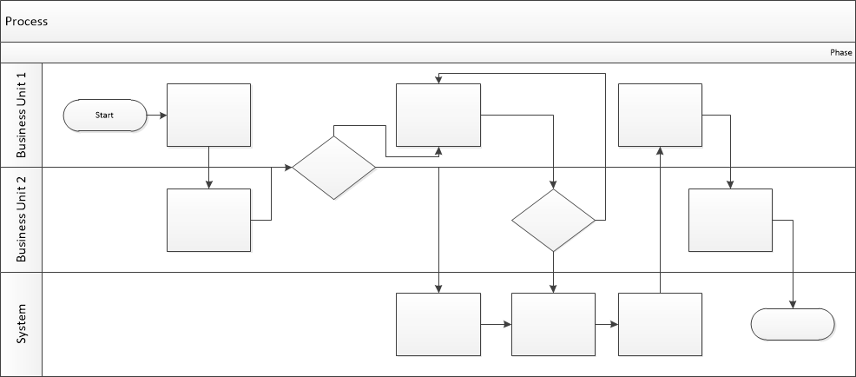

Proposed Business Process (To-Be)
- User enters destination via auto-complete, selects dates, and specifies guest details.
- System queries the real-time database and returns filtered/sorted results within 1-2 seconds.
- System displays hotel cards with total period pricing, promotional tags, and distance metrics.
- User applies granular filters (price slider, review score, amenities) or switches to map view.
- System updates inventory dynamically to hide fully booked rooms instantly.

Stakeholder Requirements

The requirements in this document are prioritized as follows:
Value | Rating | Description
1 | Critical | This requirement is critical to the success of the project. The project will not be possible without this requirement.
2 | High | This requirement is high priority, but the project can be implemented at a bare minimum without this requirement.
3 | Medium | This requirement is somewhat important, as it provides some value but the project can proceed without it.
4 | Low | This is a low priority requirement, or a “nice to have” feature, if time and cost allow it.
5 | Future | This requirement is out of scope for this project, and has been included here for a possible future release.

Stakeholder Requirements (SR)
The requirements of key stakeholders within the defined scope are detailed below:
SR ID | Priority | Stakeholder | Stakeholder Need / Requirement | Mapped Solution Requirements
SR-001 | 1 | Traveler (End User) | The traveler needs to quickly find destinations and properties with auto-complete suggestions (avoiding manual typing errors), and specify travel dates and party composition (including children's ages) to receive accurate availability and pricing. | FR-G-001, NFR-001
SR-002 | 1 | Traveler (End User) | The traveler needs to view transparent total stay pricing upfront (inclusive of base taxes and fees), primary room photos, review ratings, and distance to key city landmarks directly on hotel cards to make fast booking decisions without hidden fees. | FR-G-002
SR-003 | 1 | Traveler (End User) | The traveler needs flexible filtering by nightly price slider, high review score (8+), free cancellation, and essential amenities (Wi-Fi, parking, breakfast) to easily narrow down options matching their budget and preferences. | FR-G-003, NFR-003
SR-004 | 1 | Traveler (End User) | The traveler needs to explore search results on an interactive map across desktop and mobile viewports to evaluate spatial proximity and surrounding infrastructure. | FR-G-004, NFR-003
SR-005 | 1 | Hotel Partner / Owner | The hotel partner needs real-time bi-directional room availability and rate synchronization with their Channel Manager to eliminate overbooking risks and prevent bookings for occupied rooms. | FR-A-001, NFR-002
SR-006 | 1 | Business Owner (TravelMate) | The business owner needs priority-based search ranking ("Recommended", "Best Price") and promotional tags to highlight preferred inventory and increase search-to-booking conversion and platform revenue. | FR-G-005
SR-007 | 2 | Business Owner (TravelMate) | The business owner needs analytics logging for search queries yielding zero results to identify supply shortages in specific geographic regions and expand hotel partner acquisition. | FR-R-001
SR-008 | 1 | Traveler & Business Owner | Both travelers and business owners require consistent sub-2-second search and filter responsiveness with 99.9% uptime even during seasonal traffic spikes. | NFR-001, NFR-004
SR-009 | 1 | System Administrator & Security Officer | The IT and security team needs search endpoints protected against injection and DDoS attacks, and end-to-end data encryption across all communications. | FR-S-001, NFR-005

Functional Requirements

Req# | Priority | Description | Rationale | Stakeholder Req Ref | Use Case Reference | Impacted Stakeholders
General / Base Functionality
FR-G-001 | 1 | System shall provide an auto-complete destination input field and interactive calendar supporting check-in/out dates and children's age inputs. | Ensures accurate search parameters critical for pricing and availability. | SR-001 | UC-SRC-01 | Users, Business Owners
FR-G-002 | 1 | System shall render hotel cards displaying the total period price, review score, primary room photo, and distance to the city center. | Helps users make informed booking decisions at a glance. | SR-002 | UC-SRC-01 | Users
FR-G-003 | 1 | System shall support core filters: Price per night slider, Review Score (8+), Free Cancellation, and Amenity checkboxes. | Enhances user experience by narrowing down options based on personal preferences. | SR-003 | UC-SRC-02 | Users
FR-G-004 | 1 | System shall display a map view toggle directly from the search results list, optimized for mobile and desktop viewports. | Critical for travelers on-the-go seeking location context. | SR-004 | UC-SRC-03 | Users
FR-G-005 | 1 | System shall sort search results based on business logic, prioritizing "Recommended" and "Best Price" options with marketing tags. | Maximizes conversion rates and highlights partner properties. | SR-006 | UC-SRC-01 | Business Owners
Security Requirements
FR-S-001 | 1 | System shall secure all search and query endpoints against injection and DDoS attacks. | Protects platform infrastructure and user session data. | SR-009 | N/A | System Administrators
Reporting Requirements
FR-R-001 | 2 | System shall log zero-result filter queries for business intelligence and inventory expansion analysis. | Allows business owners to identify supply gaps in specific regions and onboard new partners. | SR-007 | N/A | Business Owners
Audit Requirements
FR-A-001 | 1 | System shall maintain an audit log of real-time inventory synchronization events via API/Channel Manager. | Ensures traceability of room availability changes. | SR-005 | N/A | System Administrators

FR-A-002 | 1 | System shall execute bi-directional real-time inventory and rate synchronization with hotel Channel Manager APIs. | Prevents overbookings and keeps rates updated across platforms. | SR-005 | N/A | Hotel Partners, System

Non-Functional Requirements
ID | Requirement | Stakeholder Req Ref | Metric / Criteria
NFR-001 | The search module must handle up to 5,000 concurrent user search queries with a maximum response time of 2.0 seconds. | SR-001, SR-008 | <= 2.0 s response @ 5,000 CCU
NFR-002 | Room availability status must synchronize via API/Channel Manager within 3 seconds of a booking update. | SR-005 | <= 3 s end-to-end sync
NFR-003 | The user interface must be fully responsive across mobile, tablet, and desktop devices. | SR-001, SR-002, SR-003, SR-004 | Responsive design (WCAG 2.1 AA compliant)
NFR-004 | The system must maintain 99.9% uptime availability for the search and filtering engine. | SR-008 | >= 99.9% SLA uptime
NFR-005 | Data transmission between the client application and search servers must be encrypted using TLS 1.3. | SR-009 | TLS 1.3 protocol compliance

Appendices

List of Acronyms
BRD: Business Requirements Document
API: Application Programming Interface
UI: User Interface
CCU: Concurrent Users
DDoS: Distributed Denial of Service
SLA: Service Level Agreement
TLS: Transport Layer Security

Glossary of Terms
Channel Manager: A software tool used by hotels to sync inventory and rates across multiple booking platforms in real time.
Auto-complete: A search feature that predicts or suggests destination and hotel names as the user types.
Zero-Result Query: A search request where the applied criteria (dates, filters, location) return no available properties.

Related Documents

TravelMate User Survey Results (Internal Document)
Business Owner Interview Transcript (Internal Document)

